**Implementation Overview**

* Our program was implemented in Java Swing using IntelliJ IDEA and Eclipse.

**Development Phase 1**

|  |  |
| --- | --- |
| **Features** | **Implementation** |
| Canvas | A JPanel that modifies the inherited paintComponent method draw the image and user modifications. |
| Empty menu and tabs | Collapsable JPanels (with shortcut keys “1” and “2”) |
| New Canvas | A JButton that clears the Canvas. |
| Save File | A JButton that takes a snapshot of the Canvas and saved it as “Saved_iImage.jpg” in the current directory. |
| Open File | Opens up the default JFileChooser for the user to select an image file. Gives an error pop-up if the file is not an image file. |

**Testing: Subjective Evaluation**

Typically, the diagnostic evaluations are performed with trained panels of experts whereas subjective evaluations are done with consumers.

A subjective evaluation for a program based on our **initial design** was carried out between friends on campus. Evaluators received a sheet of paper with simple photo-editing tasks which can all be done with the tools given in the program. The evaluators were asked to complete these tasks without any help. Observations of their mood, feelings and verbal responses were recorded during the test.

|  |  |  |  |
| --- | --- | --- | --- |
| **Evaluator** | **Significant Quote** | **Time to Complete** | **Comment** |
| Eugene Schulze | “Where is the brush size?” | 0:57 | “The menu is too crowded and too many options.” |
| Thomas Irwin | “Crap, I messed up. ” | ------  [evaluator gave up] | “Why is there no eraser??? I shouldn’t have to reset the entire board!” |
| Jana Wong | “What does this button do?” | 1:31 | “This is why I stick with Microsoft Paint.” |
| Randal Gonzalez | “Easy peasy lemon squeezy” | 0:34 | “Noice, so how much are you selling it for?” |
| Casey Mathis | “L-A-B C-M-Y-K? What’s all these letters?” | 0:53 | “All I know is R-G-B.” |

From our lectures, we remembered that users often try to find the easiest (may not be most efficient) way to complete a task when using a Human-Computer Interface, so we made a few adjustments in the final design based on the feedback we received.

**Final Design**

After a couple of iterations, we made a few changes to our initial design.

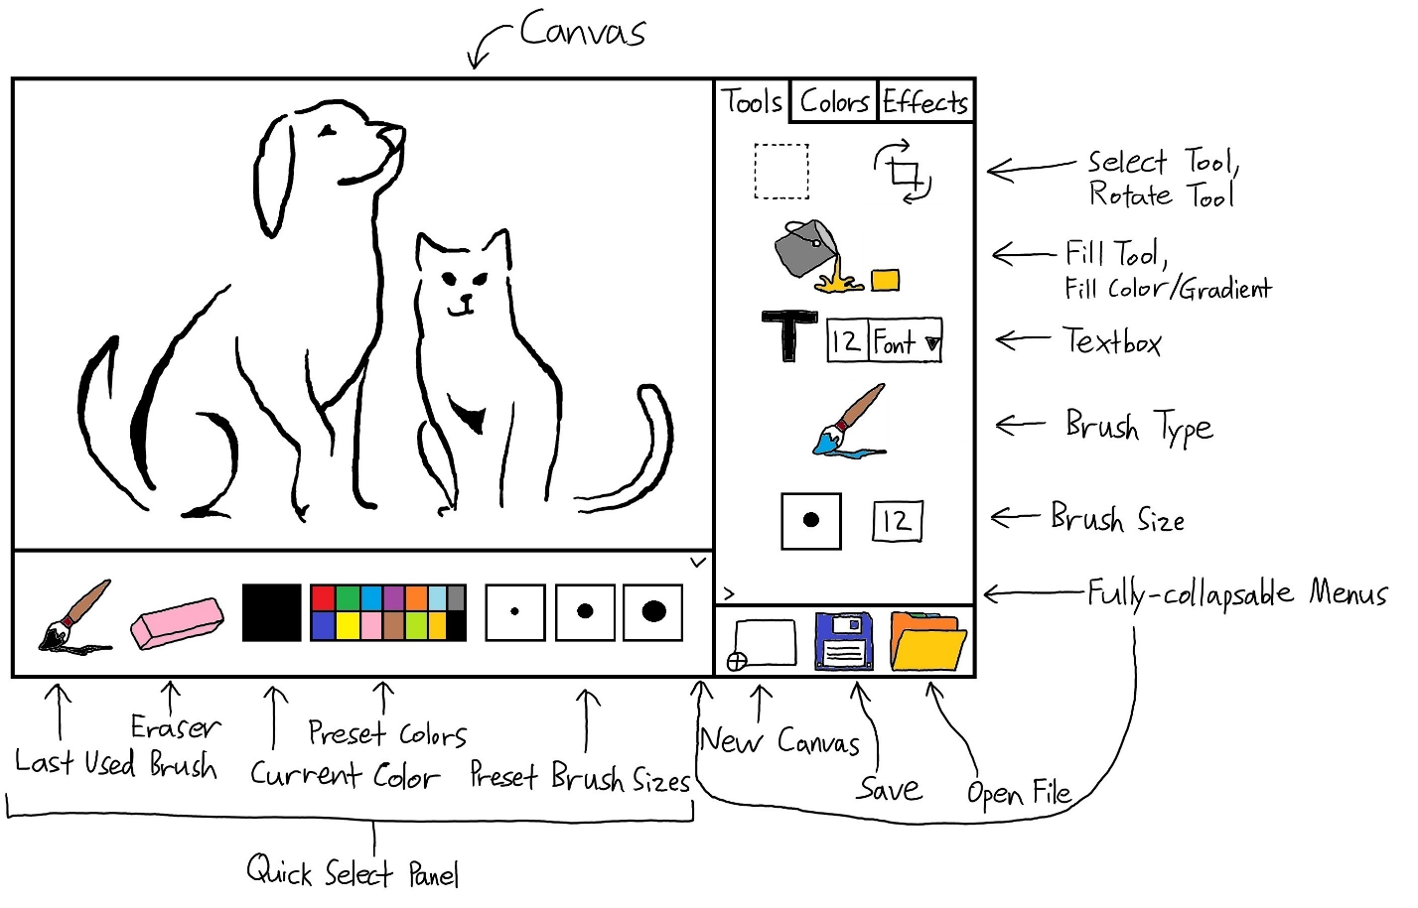

We moved the toolbelt menu to the right. Most people read/view from left to right. Thus, the components on the left comes first and is viewed as more important. In this case, the canvas.

We added a quick select panel at the bottom for easy access to the most frequently used features without pulling up the toolbelt menu (can be hidden).

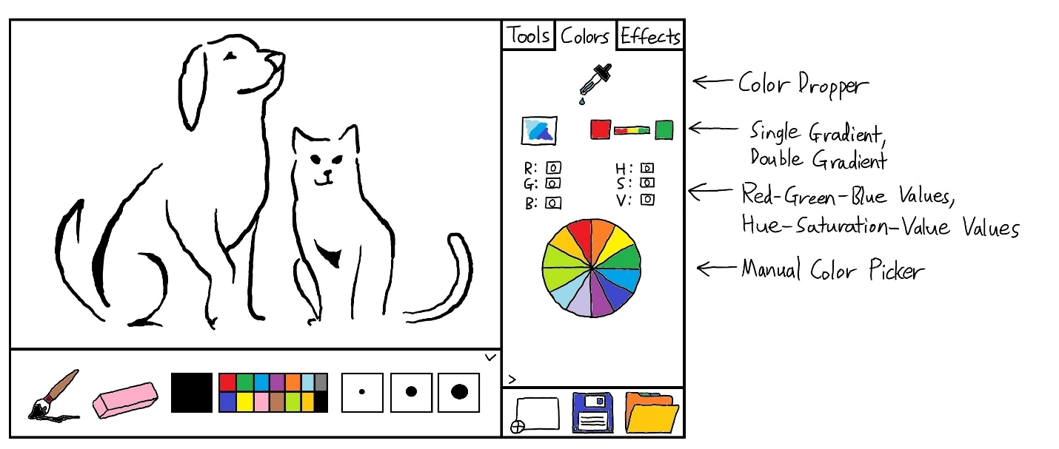

We removed unpopular color models such as L-A-B, C-M-Y-K in favor of R-G-B for simplicity.

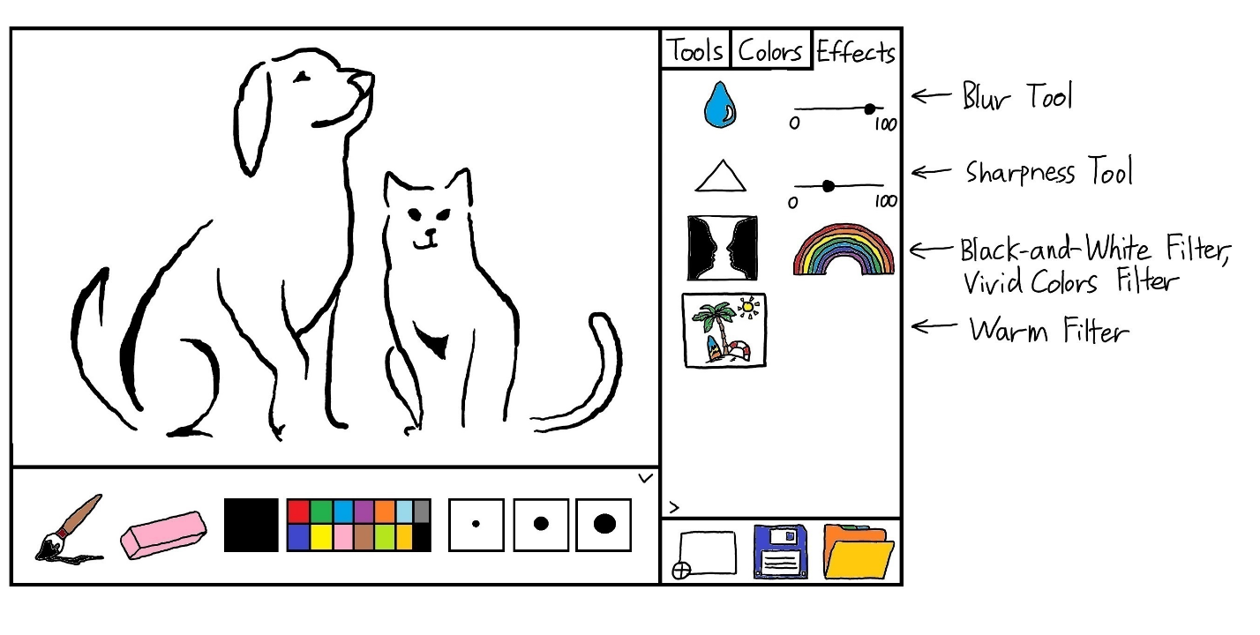

We altered some icons images for clarity.

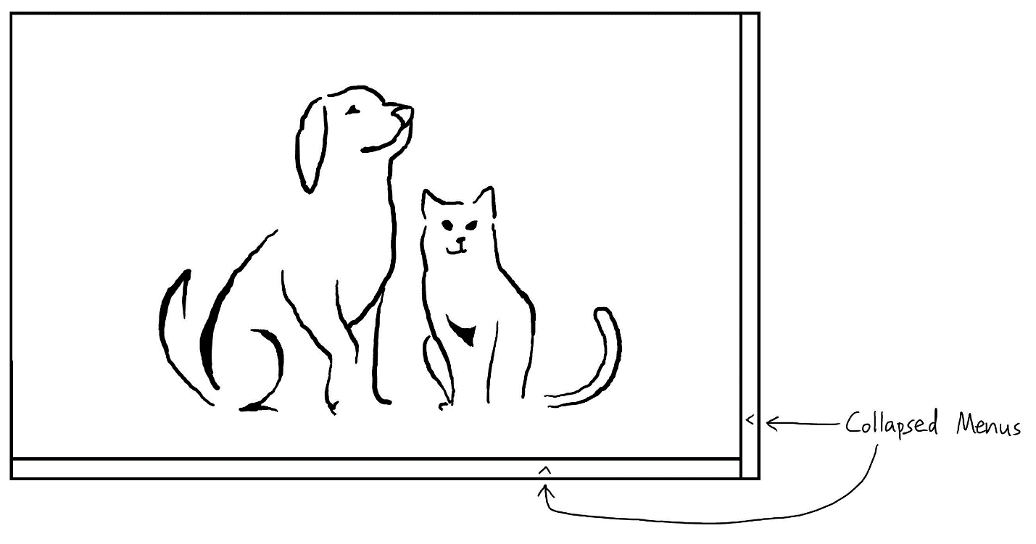

Both panels/menus are fully collapsible.